WEB DEVELOPMENT INTERNSHIP.

LEVEL 1:

TASK 1: index.html file

<!DOCTYPE html>

<html lang="en">

<head>

<meta charset="UTF-8">

<meta name="viewport" content="width=device-width, initial-scale=1.0">

<title>Your Name - Portfolio</title>

<link rel="stylesheet" href="styles.css">

</head>

<body>

<!-- Header Section -->

<header align="center" id="header">

<div class="container">

<h1>Samruddhi mahesh Gogarkar</h1>

<p>Web Developer | Designer</p>

</div>

</header>

<!-- About Section -->

<section align="center" id="about">

<div class="container">

<h2>About </h2>

<div class="about-content">

<img src="1.jpg" width="104" height="142">

<p>I am persuing my final year in computer science and Engineering at jawaharlal Darda Institude of Engineering and Technology Yavatmal.</p>

</div>

</div>

</section>

<!-- Skills Section -->

<section align="center" id="skills">

<div class="container">

<h2>Skills</h2>

<ul>

<li>HTML</li>

<li>CSS</li>

<li>Java</li>

<li>Web Development</li>

<li>python</li>

<!-- Add more skills as needed -->

</ul>

</div>

</section>

<!-- Projects Section -->

<section align="center" id="projects">

<div class="container">

<h2>Projects</h2>

<div class="project">

<img src="project1.jpg" alt="Project 1">

<div class="project-info">

<h3>Weather forecasting</h3>

<p>In this project I did the project based on weather changes counting each nd every changes of weather.</p>

<a href="#">View Project</a>

</div>

</div>

<!-- Add more projects as needed -->

</div>

</section>

<!-- Resume Section -->

<section align="center" id="resume">

<div class="container">

<h2>Resume</h2>

<p>Download my resume <a href="#">here</a>.</p>

</div>

</section>

<!-- Contact Section -->

<section align="center" id="contact">

<div class="container">

<h2>Contact Me</h2>

<p>Email: samruddhigogarkar@gmail.com</p>

<p>Phone:7387722313</p>

</div>

</section>

<!-- Footer Section -->

<footer align="center" id="footer">

<div class="container">

<p>&copy; 2024 Your Name. All rights reserved.</p>

<ul>

<li><a href="#">LinkedIn</a></li>

<li><a href="#">GitHub</a></li>

<li><a href="#">Twitter</a></li>

<!-- Add more social links or information -->

</ul>

</div>

</footer>

</body>

</html>

<!DOCTYPE html>

<html lang="en">

<head>

<meta charset="UTF-8">

<meta name="viewport" content="width=device-width, initial-scale=1.0">

<title>Your Name - Portfolio</title>

<link rel="stylesheet" href="styles.css">

</head>

<body>

<!-- Header Section -->

<header align="center" id="header">

<div class="container">

<h1>Samruddhi mahesh Gogarkar</h1>

<p>Web Developer | Designer</p>

</div>

</header>

<!-- About Section -->

<section align="center" id="about">

<div class="container">

<h2>About </h2>

<div class="about-content">

<img src="1.jpg" width="104" height="142">

<p>I am persuing my final year in computer science and Engineering at jawaharlal Darda Institude of Engineering and Technology Yavatmal.</p>

</div>

</div>

</section>

<!-- Skills Section -->

<section align="center" id="skills">

<div class="container">

<h2>Skills</h2>

<ul>

<li>HTML</li>

<li>CSS</li>

<li>Java</li>

<li>Web Development</li>

<li>python</li>

<!-- Add more skills as needed -->

</ul>

</div>

</section>

<!-- Projects Section -->

<section align="center" id="projects">

<div class="container">

<h2>Projects</h2>

<div class="project">

<img src="project1.jpg" alt="Project 1">

<div class="project-info">

<h3>Weather forecasting</h3>

<p>In this project I did the project based on weather changes counting each nd every changes of weather.</p>

<a href="#">View Project</a>

</div>

</div>

<!-- Add more projects as needed -->

</div>

</section>

<!-- Resume Section -->

<section align="center" id="resume">

<div class="container">

<h2>Resume</h2>

<p>Download my resume <a href="#">here</a>.</p>

</div>

</section>

<!-- Contact Section -->

<section align="center" id="contact">

<div class="container">

<h2>Contact Me</h2>

<p>Email: samruddhigogarkar@gmail.com</p>

<p>Phone:7387722313</p>

</div>

</section>

<!-- Footer Section -->

<footer align="center" id="footer">

<div class="container">

<p>&copy; 2024 Your Name. All rights reserved.</p>

<ul>

<li><a href="#">LinkedIn</a></li>

<li><a href="#">GitHub</a></li>

<li><a href="#">Twitter</a></li>

<!-- Add more social links or information -->

</ul>

</div>

</footer>

</body>

</html>

TASK 1: style.css file

/* Reset some default styles */

* {

margin: 0;

padding: 0;

box-sizing: border-box;

}

body {

font-family: Arial, sans-serif;

line-height: 1.6;

background-color: #f0f0f0;

}

.container {

width: 80%;

max-width: 1200px;

margin: 0 auto;

padding: 20px;

}

header {

background-color: #333;

color: #fff;

text-align: center;

padding: 20px 0;

}

header h1 {

font-size: 2.5rem;

margin-bottom: 10px;

}

header p {

font-size: 1.2rem;

}

section {

padding: 40px 0;

}

section h2 {

text-align: center;

margin-bottom: 20px;

}

.about-content {

display: flex;

justify-content: center;

align-items: center;

flex-wrap: wrap;

}

.about-content img {

width: 200px;

height: 200px;

border-radius: 50%;

margin-right: 20px;

}

.skills ul {

list-style-type: none;

display: flex;

justify-content: center;

align-items: center;

flex-wrap: wrap;

}

.skills li {

margin: 5px;

padding: 10px 20px;

background-color: #333;

color: #fff;

border-radius: 20px;

}

.projects {

display: grid;

grid-template-columns: repeat(auto-fit, minmax(300px, 1fr));

gap: 20px;

}

.project {

background-color: #fff;

border: 1px solid #ddd;

padding: 20px;

border-radius: 10px;

overflow: hidden;

}

.project img {

width: 100%;

height: auto;

border-radius: 5px;

}

.project-info {

padding: 10px;

}

.project-info h3 {

margin-bottom: 10px;

}

.contact {

text-align: center;

}

footer {

background-color: #333;

color: #fff;

text-align: center;

padding: 10px 0;

}

footer ul {

list-style-type: none;

padding: 0;

}

footer ul li {

display: inline-block;

margin: 0 10px;

}

footer ul li a {

color: #fff;

text-decoration: none;

}

footer ul li a:hover {

text-decoration: underline;

}

OUTPUT:

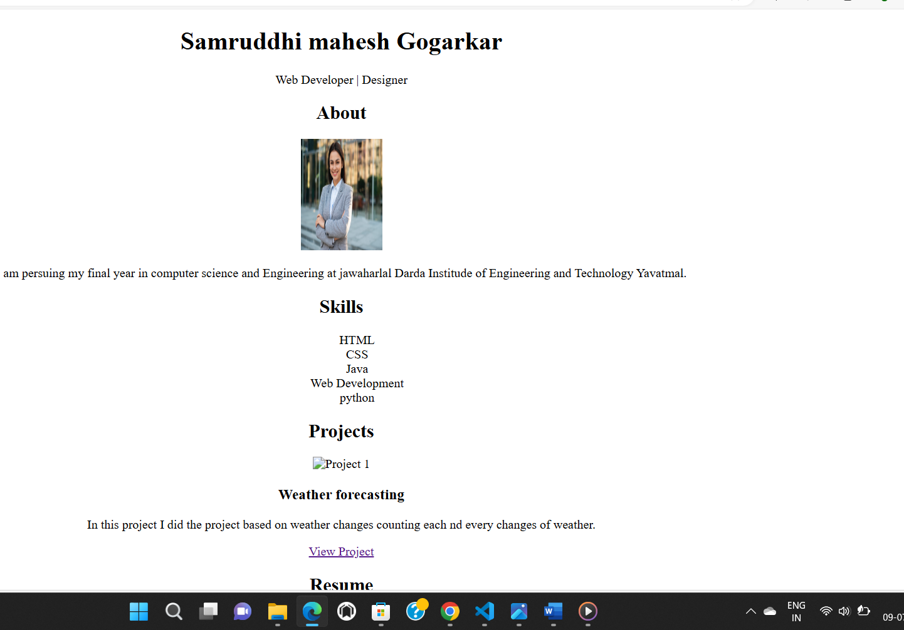

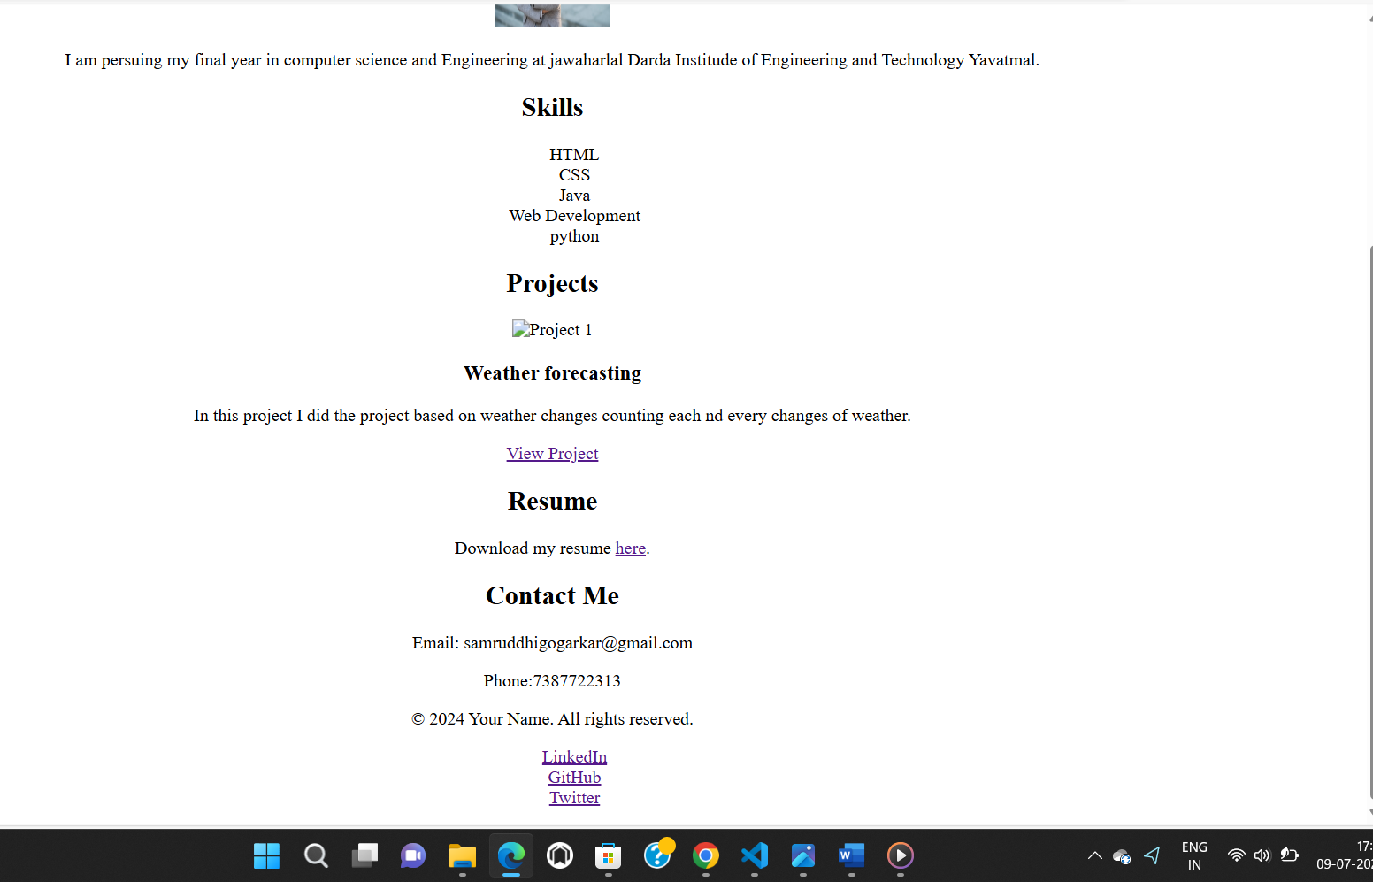

TASK 2:html file

<!DOCTYPE html>

<html lang="en">

<head>

<meta charset="UTF-8">

<meta name="viewport" content="width=device-width, initial-scale=1.0">

<title>Document</title>

<link rel="stylesheet" href="style.CSS">

</head>

<body>

<nav>

<h1>COOKIES</h1>

<ul>

<li><a>HOME</a></li>

<li><a>ORDER'S</a></li>

<li><a>VARIETY</a></li>

<li><a>CONTACT</a></li>

</ul>

</nav>

<!--MAIN PAGE-->

<div class="container">

<div class="text">

<h1>CAKE'S.</h1>

<p>Soft and crisp by COOKIE'S<br>

Softness that fall in love with cakes...</p>

<button>View More</button>

</div>

<img src="cake.jpeg" alt="">

</div>

</body>

</html>

TASK 2: CSS file

*{

margin: 0%;

padding: 0%;

}

body{

background-color: black;

color: white;

}

nav{

display: flex;

justify-content: center;

justify-content: space-around;

margin-top: 26px;

}

ul{

display: flex;

list-style: none;

}

nav h1{

font-size: 35px;

}

ul li a{

margin-inline: 30px;

font-size: 24px;

border-bottom: 3px solid rgb(238,8,8);

border-radius: 3px;

cursor: pointer;

}

ul li a:hover{

border: 2px solid white;

}

img{

width: 45%;

}

.container{

display: flex;

justify-content: center;

justify-content: space-around;

margin-top: 50px;

}

.container .text{

margin-top: 40px;

}

.text h1{

font-size: 120px;

}

.text p{

font-size: 26px;

margin-top: 20px;

}

.text button{

width: 160px;

height: 40px;

background-color: rgb(238,12,12);

color: white;

font-size: 26px;

border: none;

margin-top: 50px;

}

.text button:hover{

background-color: brown;

cursor: pointer;

OUTPUT:

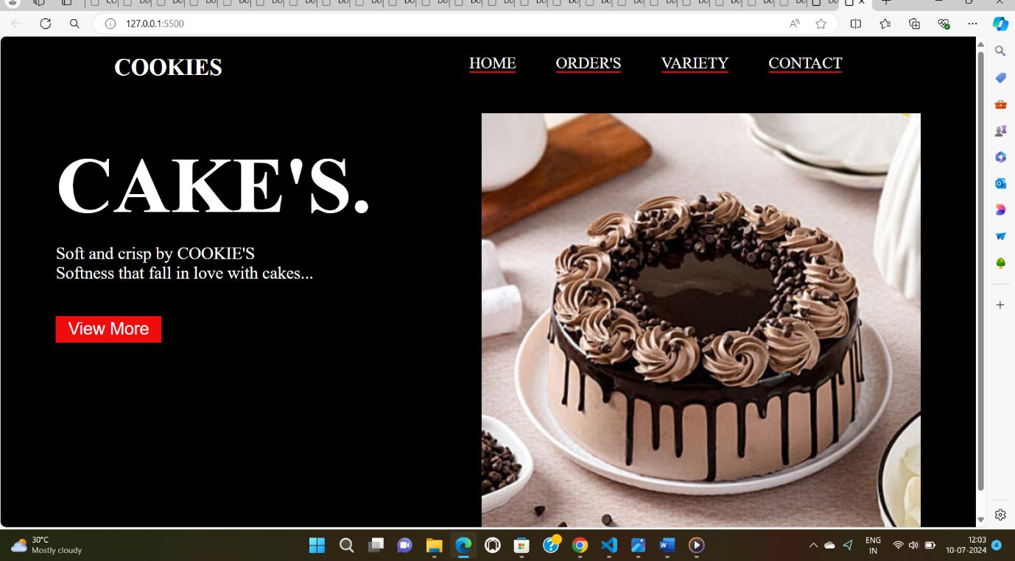

TASK 3: index.html file

<!DOCTYPE html>

<html lang="en">

<head>

    <meta charset="UTF-8">

    <meta name="viewport" content="width=device-width, initial-scale=1.0">

    <link rel="stylesheet" href="style.css">

    <title>Calculator</title>

</head>

<body>

    <div class="container">

        <div class="calculator">

            <input type="text" placeholder="0" id="result">

    <button onclick="clrs()">AC</button>

    <button onclick="dle()">DEL</button>

    <button onclick="display('%')">%</button>

    <button onclick="display('/')">/</button>

    <button onclick="display('7')">7</button>

    <button onclick="display('8')">8</button>

    <button onclick="display('9')">9</button>

    <button onclick="display('x')">X</button>

    <button onclick="display('4')">4</button>

    <button onclick="display('5')">5</button>

    <button onclick="display('6')">6</button>

    <button onclick="display('+')">+</button>

    <button onclick="display('1')">1</button>

    <button onclick="display('2')">2</button>

    <button onclick="display('3')">3</button>

    <button onclick="display('-')">-</button>

    <button onclick="display('0')">0</button>

    <button onclick="display('.')">.</button>

    <button class="equal" onclick="calculate()">=</button>

        </div>

    </div>

    <script src="index.js"></script>

</body>

</html>

Style.css file

*{

    margin: 0%;

    padding: 0%;

    box-sizing: border-box;

    font-family: sans-serif;

    font-weight: bold;

    font-size: 22px;

    color: #ff6525;

    background-color: #ecf0f3;

}

.container{

    height: 100vh;

    display: flex;

    justify-content: center;

    align-items: center;

}

.calculator{

border-color: #ecf0f3;

padding: 15px;

border-radius: 30px;

box-shadow: inset 5px 5px 12px #fff,  5px 5px 12px rgba(0, 0, 0,0.14);

display: grid;

grid-template-columns:repeat(4,70px);

}

input{

    grid-column: span 4;

    width: 260px;

    height: 70px;

    background-color: #ecf0f3;

    border: none;

    box-shadow: inset -5px 12px #fff,

                inset 5px 5px 12px rgba(0, 0, 0,0.14);

                border-radius: 30px;

                outline: none;

                font-size: 50px;

                text-align: end;

                margin: 40px auto;

                padding: 10px;

}

input::placeholder{

    color: #ff6525;

}

button{

    width: 48px;

    height: 48;

    background-color: #ecf0f3;

    box-shadow:  -5px -5px 12px #fff,

                 5px 5px 12px rgba(0, 0, 0,0.14);

                border-radius: 50px;

                border:none;

                margin: 8px auto;

}

.equal{

    width: 115px;

    border-radius: 40px;

    margin: 8px 12px;

}

Index.js file

var result = document.getElementById("result");

function display(number){

    result.value += number;

}

function calculate(){

    var final_number = result.value;

    var final_result = eval(final_number);

    result.value = final_result;

}

function clrs(){

    result.value = "";

}

function dle(){

    result.value = result.value.slice(0,-1);

}

OUTPUT:

